STRUCTURED FOUNDATION REPAIRS, INC.

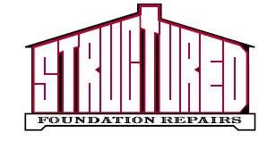

CERTIFY TO ALL THAT TOM KIDD HAS RECEIVED A LIFETIME TRANSFERABLE WARRANTY ON THIRTEEN ( 13 ) CONCRETE PILINGS UNDER THE PROVISIONS AND TERMS OF THE GENERAL CONDITIONS ON THE AGREEMENT DATED 4/18/2019 FOR THE PROPERTY LOCATED AT 13301 TRINITY BLVD SUITE 133 EULESS TX 76040

________ ________________________________________________________
Authorized Signature Date

* See reverse for general conditions and transfer instructions

